1. The verb 'wish' - Wishes

The verb 'wish' indicates that the speaker wants reality to be different.

I **wish** John **was** here.

The use of the [past](https://portal.speexx.com/articles/7772498/standard-packet/7350/exercise/1#165388) or [past perfect tense](https://portal.speexx.com/articles/7772498/standard-packet/7350/exercise/1#165485) indicates that the situation is impossible or unlikely.

I **wish** I **had** a million dollars.  
I **wish** I **had been** there.

Wish + 'would' + [infinitive](https://portal.speexx.com/articles/7772498/standard-packet/7350/exercise/1#613171) expresses a desire that someone do something differently.

I **wish** you **would** tidy your room.  
I **wish** you **wouldn't** shout so loudly.

1. Idioms

**to not take one's eyes off someone**  
= to not be able to stop looking at someone  
**to talk behind someone's back**  
= to speak negatively about people when they're not there  
**to have butterflies in one's stomach**  
= to feel nervous  
**to get something off one's chest**  
= to talk about something that has been worrying you

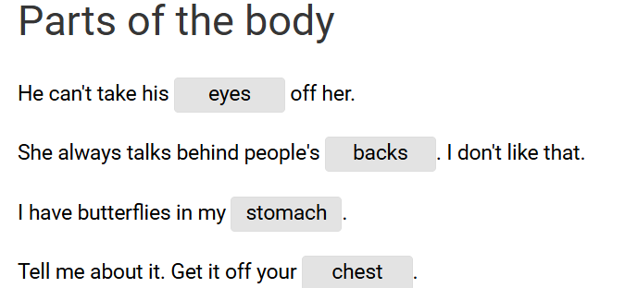

1. Idioms

|  |
| --- |
| **put one's foot down** | = | use one's authority to stop sth from happening |
| **cry one's eyes out** | = | cry a lot |
| **laugh one's head off** | = | laugh a lot |
| **pour one's heart out** | = | tell one's secret feelings and worries |
| **put one's hand out** | = | hold one's hand out |
| **do one's knees in** | = | damage one's knees |
| **put one's hands up** | = | hold one's hands up in the air |

